# Question - 1

Answer the following in the context of the Linux Operating System. You must write all the commands that you have used for answering the questions. Also, attach printout OR a file (may be in pdf format) containing the screenshots of the output.

**a)** - Write and run the following Linux commands and attach the screenshots of the output of each commands: 10 marks

1. who
2. man
3. cat
4. cp
5. chmod
6. ls
7. cmp
8. cd
9. mkdir
10. grep

**Answer**

i) who

ii) man

iii) cat

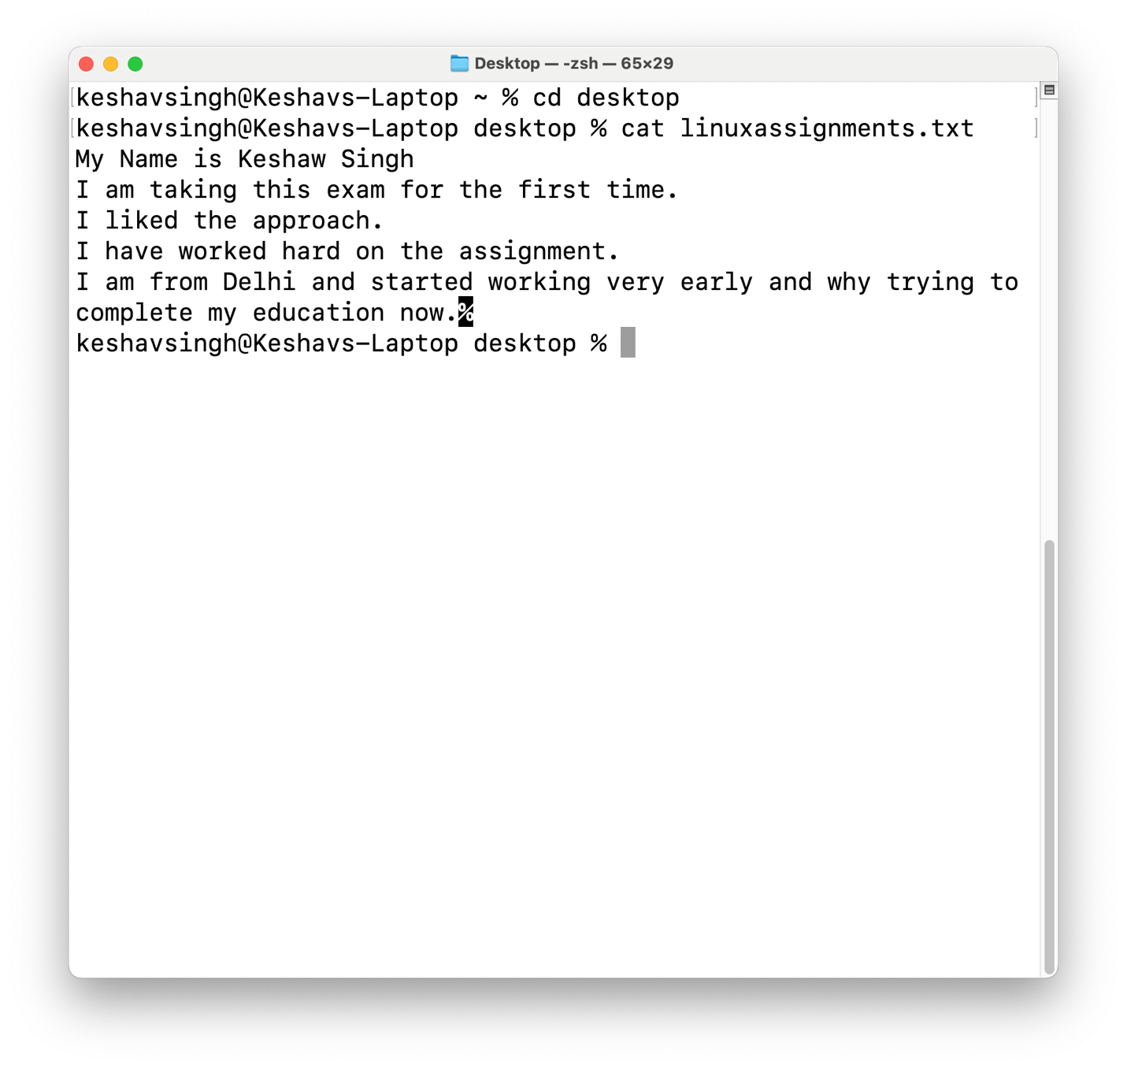

iv) cp

v) chmod

vi) ls

vii) cmp

viii) cd

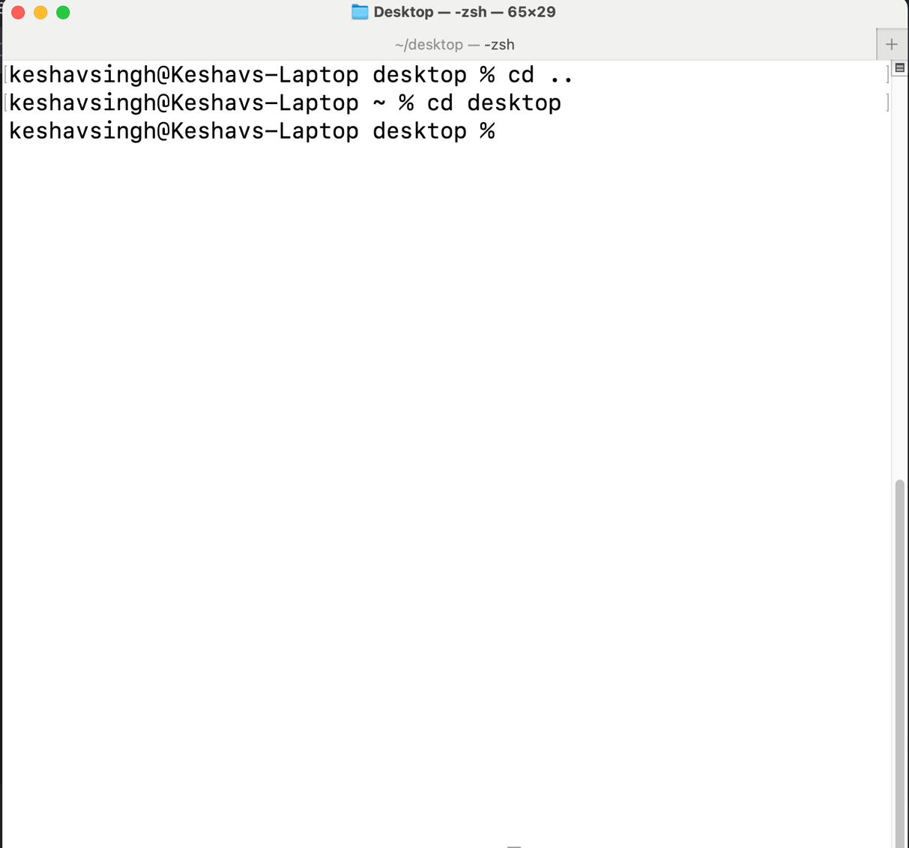

ix) mkdir

x) grep

## b) - Create a text file in Linux consisting of 25 lines. Display the first 4 and last 4 lines of this file.

Count how many times the word “the” appeared in this file’ Display the permissions of the file created by you. Now, change the file permissions of this file to rw-rw—-. 6 Marks

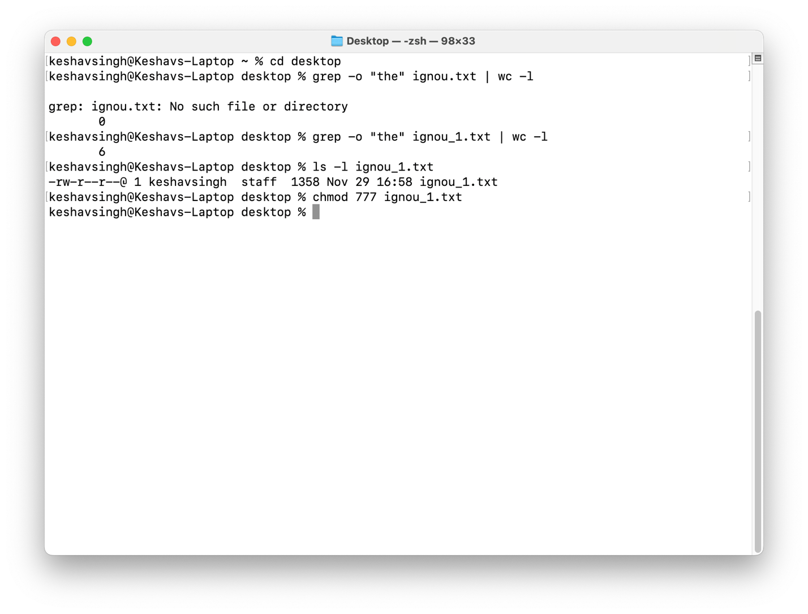

# Q - 2

Create a presentation using any Presentation software on the topic Solar Power - (minimum 10 slides) having the following features: 16 Marks

1. All slides should use a common design template.
2. Add an audio file to a slide. Also, add a video file that should run on a full-screen
3. All the slides should have timer-based transitions.
4. All the slides should have proper headings and slide notes. v) Each slide should have one image related to the topic.

Write the sequence of steps that you have performed to create these slides. Also attach printout OR a file (may be in pdf format) containing the handout of all the slides (6 slides per page)

**Answer**:

Steps to Create a PowerPoint Presentation

**1. Open PowerPoint:** Launch the PowerPoint application on your computer.

**2. Create a New Presentation:** Click on “File” and then “New.” * Choose a blank presentation or select a pre-designed template.

**3. Design Your Title Slide:** Add a title to your presentation. * Include your name, the date, and any other relevant information. * Choose a visually appealing background and font.

**4. Add Slides:** Click on the “New Slide” button to add new slides. * Choose a suitable layout for each slide, such as title and content, title only, or blank.

**5. Add Content to Slides:**

* **Text:** Use text boxes to add headings, subheadings, and body text.
* **Images:** Insert images from your computer or online sources.
* **Shapes:** Use shapes to create diagrams, flowcharts, or other visual elements.
* **SmartArt:** Add pre-designed diagrams and charts to visualize information.
* **Tables:** Create tables to organize data.
* **Charts:** Use charts to present data visually.

**6. Format Your Slides:**

* **Font:** Choose a clear and readable font for your text.
* **Font Size:** Adjust the font size to suit the content and slide size.
* **Color Scheme:** Select a color scheme that is visually appealing and easy to read.
* **Background:** Choose a suitable background color or image.
* **Layout:** Arrange elements on the slide to create a visually balanced and informative layout.

**7. Add Transitions and Animations:**

* **Transitions:** Apply transitions between slides to create a smooth flow.
* **Animations:** Add animations to text and objects to enhance visual appeal.

**8. Review and Edit:**

* Proofread your content for errors and typos.
* Ensure that the slides are visually appealing and easy to understand.
* Make any necessary adjustments to the layout, formatting, or content.

**9. Present Your Slideshow:** * Use PowerPoint’s presentation mode to deliver your presentation. * Practice your presentation to ensure a smooth delivery. * Use a laser pointer or other visual aids to highlight key points. * Answer questions from your audience.

**Additional Tips:**

* **Keep it Simple:** Avoid cluttering your slides with too much text or images.
* **Use High-Quality Images:** Choose high-resolution images to ensure clarity and professionalism.
* **Practice Your Presentation:** Rehearse your presentation to build confidence and timing.
* **Use Visual Aids Effectively:** Use visuals to enhance your message and keep your audience engaged.
* **Adapt to Your Audience:** Tailor your presentation to the specific needs and interests of your audience.

## **Presentation: Solar Power - A Bright Future**

# Question 3:

1. Use a Word Processor to create a document about the topics covered in BCSL013.

It should include:

1. A multi-level list highlighting the topics and subtopics of the Units;
2. A table consisting of unit number, unit title, and number of pages of that unit; (iii) a paragraph about the objectives of the course. 6 Marks
3. Design a flyer on the topic solar power, Use different styles, size, fonts, colors and effects.

Write the sequence of steps that you have performed to create the document and flyer. Also attach a printout OR a file (may be in pdf format) containing document and flyer.

# Question 4:

Create a worksheet containing the payroll of a company as given in the following table, Write the sequence of steps that you have performed to create the formulae in different cells:

| Employee Name | Basic Salary (B) | Dearness Allowance (DA) (30% of B) | Total Gross Salary (G) | Income Tax (IT) (25% of G | PF (10% of G) | Net Salary (N) |
| --- | --- | --- | --- | --- | --- | --- |
| Raman | 50000 |  |  |  |  |  |
| Mohit | 65000 |  |  |  |  |  |
| Siraj | 60000 |  |  |  |  |  |
| David | 50000 |  |  |  |  |  |
| Phillip | 45000 |  |  |  |  |  |
| Roger | 30000 |  |  |  |  |  |

You must enter all the labels and details as given above. You may use the following formulae: DA = 30% of B G = B + DA IT = 25% of G PF = 10% of G N = B + DA IT PF Write the sequence of steps that you have performed to create the formulae in different cells. Also attach printout OR a file (may be in pdf format) containing the worksheet.

**Answer**

Creating a Payroll Worksheet in Excel

**Here’s a step-by-step guide to create the payroll worksheet in Excel:**

1. **Create a New Worksheet:**
   * Open Microsoft Excel and create a new blank worksheet.
2. **Input the Table Headers:**
   * In the first row, input the column headers as given in the table:
     + Employee Name
     + Basic Salary (B)
     + Dearness Allowance (DA) (30% of B)
     + Total Gross Salary (G)
     + Income Tax (IT) (25% of G)
     + PF (10% of G)
     + Net Salary (N)
3. **Input Employee Data:**
   * In the rows below the headers, input the names and basic salaries of the employees.
4. **Calculate Dearness Allowance (DA):**
   * In the cell next to the first employee’s basic salary (B2), enter the formula: =B2*30%
   * This will calculate 30% of the basic salary.
   * Copy this formula down the column to calculate DA for all employees.
5. **Calculate Gross Salary (G):**
   * In the cell next to the first employee’s DA, enter the formula: =B2+C2
   * This will add the basic salary and DA to get the gross salary.
   * Copy this formula down the column to calculate G for all employees.
6. **Calculate Income Tax (IT):**
   * In the cell next to the first employee’s gross salary, enter the formula: =D2*25%
   * This will calculate 25% of the gross salary as income tax.
   * Copy this formula down the column to calculate IT for all employees.
7. **Calculate PF (Provident Fund):**
   * In the cell next to the first employee’s income tax, enter the formula: =D2*10%
   * This will calculate 10% of the gross salary as PF.
   * Copy this formula down the column to calculate PF for all employees.
8. **Calculate Net Salary (N):**
   * In the last column, enter the formula: =B2+C2-E2-F2
   * This will calculate the net salary by subtracting IT and PF from the gross salary.
   * Copy this formula down the column to calculate N for all employees.

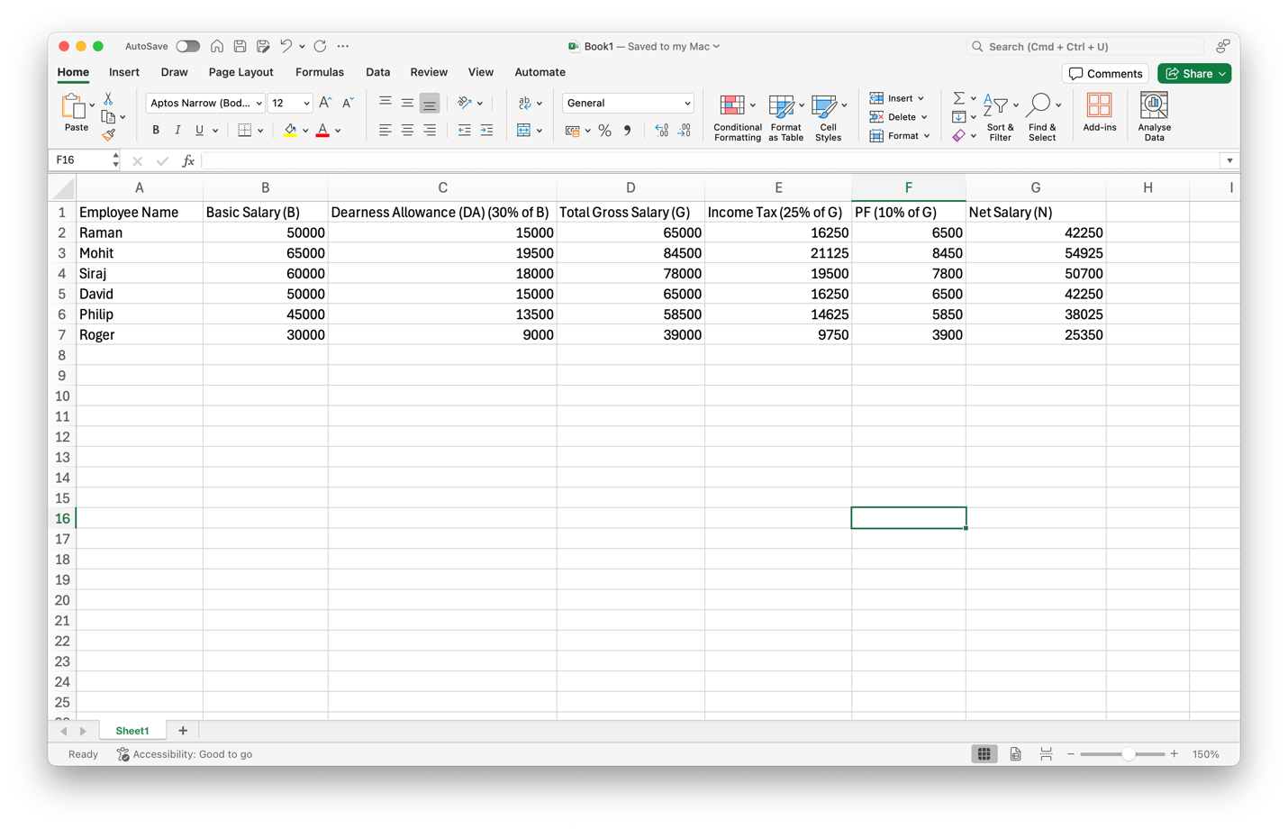

# Question 5:

Use MS Outlook or any other email software to perform the following tasks:

a) Make a weekly meeting schedule for a group meeting, along with two other BCA students, about the agenda two consecutive weeks.

**Answer**:

**Here’s how to schedule a weekly meeting using Google Calendar:**

1. **Log in to Google Calendar:** Access your Google Calendar account.
2. **Create a New Event:** Click the “Create” button.
3. **Event Details:**
   * **Title:** Give your event a clear title, like “Weekly Group Meeting.”
   * **Date and Time:** Set the start and end times for the first meeting.
   * **Repeat:** Click “Repeat” and select “Weekly.” Specify the number of weeks to repeat (e.g., 2).
   * **Guests:** Add the email addresses of your two BCA group members.
   * **Location:** If it’s an in-person meeting, add the location.
   * **Description:** Outline the agenda for the meeting.
4. **Set Reminders:** Set reminders for yourself and other attendees.
5. **Add Video Conference Link (Optional):** Add a link to a video conferencing tool like Google Meet or Zoom in the description.
6. **Save the Event:** Click “Save” to create the recurring event.

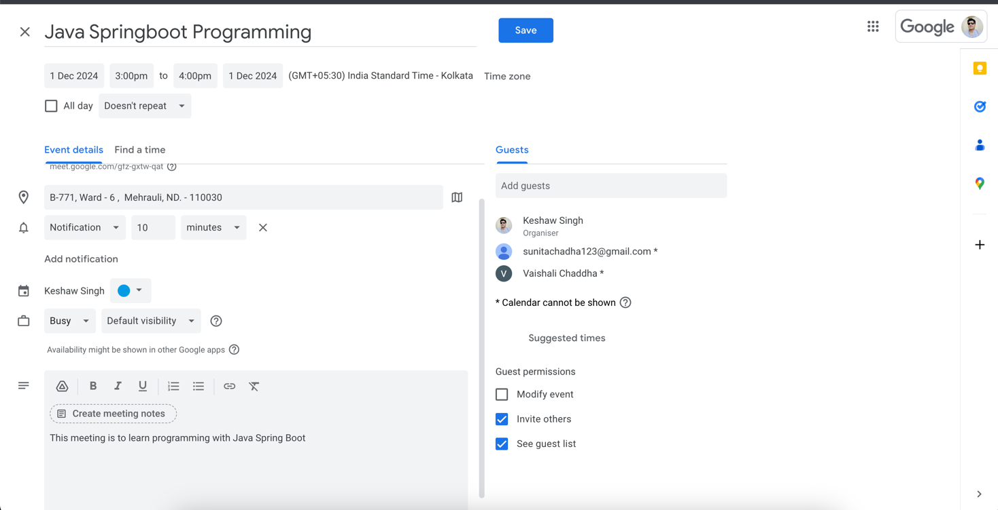

b) Write an email to your friends (at least 5) inviting them to attend a lecture which is to be presented by you. Make your Signature and add it to the e-mail message.

**Answer**

1. **Create a New Event:**
   * Click the “Create” button (usually a plus sign) to start a new event.
2. **Add Event Details:**
   * **Title:** Give your event a clear title, like “Weekly Group Meeting.”
   * **Date and Time:** Set the start and end times for the first meeting.
   * **Repeat:** Click “Repeat” and select “Weekly.” Specify the number of weeks to repeat (e.g., 2).
   * **Guests:** Add the email addresses of your two BCA group members.
   * **Location:** If it’s an in-person meeting, add the location.
   * **Description:** Outline the agenda for the meeting.
3. **Set Reminders:**
   * Set reminders for yourself and other attendees to ensure timely attendance.
4. **Add Video Conference Link (Optional):**
   * If you’re having an online meeting, add a link to a video conferencing tool like Google Meet or Zoom in the event description.
5. **Save the Event:**
   * Click “Save” to create the recurring event.

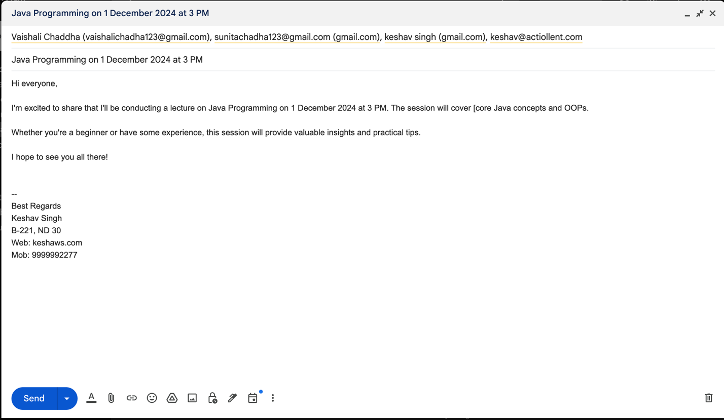

c) Create a vacation/ holiday message that should be sent to all the emails received by you in a vacation week (say 5th December, 2024 to 12th December, 2024; or 7th June, 2025 to 15th June 2025).

**Answer**:

**Here’s how to create a vacation auto-reply message in Gmail:**

1. **Go to Gmail Settings:** Click the gear icon in the top right corner and select “See all settings.”
2. **Open the “Filters” tab:** Click on the “Filters” tab.
3. **Create a New Filter:** Click on “Create a new filter.”
4. **Set Filter Criteria:**
   * In the “From” field, leave it blank to apply the filter to all incoming emails.
5. **Choose the Action:**
   * Check the box next to “Apply the label” and select a label you want to use (e.g., “Vacation”).
   * Check the box next to “Also, automatically forward it to” and enter your alternate email address (if you want).
   * Check the box next to “Archive it.”
6. **Create Filter:**
   * Click “Create filter.”
7. **Create a Vacation Responder:**
   * In the “Filters” tab, click on “Create a new filter.”
   * Set the same filter criteria as before.
   * Choose the action “Send a vacation responder.”
   * Compose your vacation reply message (e.g., “Out of Office”).
   * Set the start and end dates for your vacation (e.g., 5th December, 2024 to 12th December, 2024).
   * Click “Create filter.”

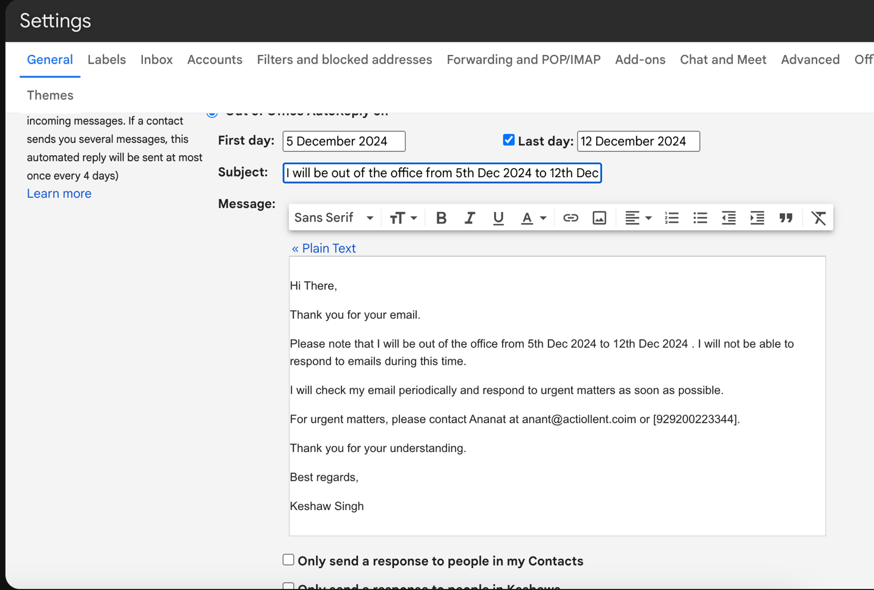

d) A person is sending several e-mails to you which you want to delete automatically. Configure your mail account to achieve this functionality in your mailbox for a specific email id. Make and state suitable assumption, if any.

**Answer**

* Go to Gmail Settings:
* Click on the gear icon in the top right corner of your Gmail inbox.  Select “See all settings.”   Navigate to Filters:
* In the Settings tab, click on the “Filters” tab.   Create a New Filter:
* Click on “Create a new filter.”   - Set the Filter Criteria:
* In the “From” field, enter the specific email address you want to filter.   You can add more specific criteria like “Subject contains” or “Has the words.”   Choose the Action:
* Check the box next to “Delete it.”Create the Filter:
* Click “Create filter.”   Now, any email from that specific sender will be automatically deleted as soon as it arrives in your inbox.

